Name:____________________________________________ Date:________________ Period: _______

Quiz 1 – Circular (5 Points)

An engineer is trying to determine the speed at which she can swing a 500 kg wrecking ball without breaking her cable. She knows that the cable is rated to withstand 7500 N of tension.
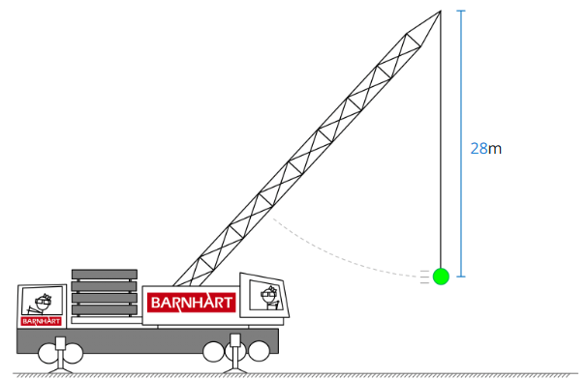
FBD

a) Draw the FBD of the ball…label the forces (ignore air resistance)
b) Determine the following when the cable is at the breaking tension (show steps and include UNITS):
Radius of curved path: _______________
Centripetal Acceleration of Ball: _____________
Net Centripetal Force on Ball: _____________
Speed of the Ball: _____________

Name:____________________________________________ Date:________________ Period: _______

Quiz 1 – Circular (5 Points) **MAKE-UP**

An engineer is trying to determine the Tension in the cord when she swings a 500 kg wrecking ball at a speed of 14 m/s.

FBD

a) Draw the FBD of the ball…label the forces (ignore air resistance)
b) Determine the following when the ball is passing through the lowest point of the path (show steps and include UNITS):
Radius of curved path: _______________
Centripetal Acceleration of Ball: _____________
Net Centripetal Force on Ball: _____________
Tension in the Chord: _____________

